Accessibility Guidelines

The University Grants Commission (UGC) introduced Accessibility Guidelines and Standards for Higher Education Institutions and Universities to ensure inclusive and accessible environments for students with disabilities. These guidelines mandate institutions to create accessibility frameworks from admission to course completion, ensuring barrier-free participation for all. The guidelines also address equitable access to curriculum, accessible library resources, and universal design for learning.

Key aspects of the UGC Accessibility Guidelines and Standards:

Inclusive Environment:

The guidelines aim to create a disability-inclusive environment for students with special needs, from the admission process to the award of marks.

Accessible Curriculum:

The guidelines emphasize equitable access to curriculum, flexible and adaptable teaching methods, and the use of Universal Design for Learning (UDL) to create an equitable classroom.

Accessible Library Resources:

Libraries should provide accessible resources and formats to ensure equitable access for all students.

Accessibility Audit:

An accessibility audit tool is being developed to assess the performance of HEIs in implementing the guidelines.

Support for HEIs:

UGC is committed to supporting HEIs in implementing the guidelines and ensuring that students with disabilities can participate in academic programs. Anwarul Uloom College of Business Management is committed to ensuring a barrier free and inclusive environment for students, staff and visitors with disabilities and special needs.

The following facilities are provided with in the campus:

* • Ramps
* • Accessible Toilets
* • Clear signage for directions, rooms and emergency exits
* • Wheel Chair facility
* • Parking areas
* • Website accessibility for all
* • Extra time and Scribe facility as per the candidate requirement

**FACILITIES FOR DIFFERENTLY ABLED**

Anwarul Uloom College is committed to providing inclusive education and support for differently-abled students. While specific details about facilities for differently-abled students are not explicitly mentioned, the college offers various amenities that can contribute to an inclusive learning environment:

**Facilities**: The college provides multiple washrooms, ensuring cleanliness and hygiene across the campus. However, specific details about washroom facilities for differently-abled students are not explicitly mentioned. It is advisable to contact the college directly for more information

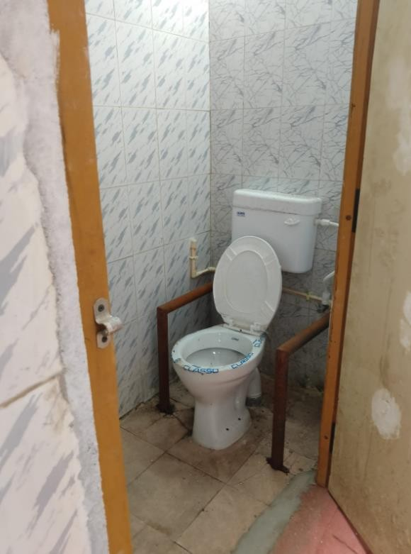

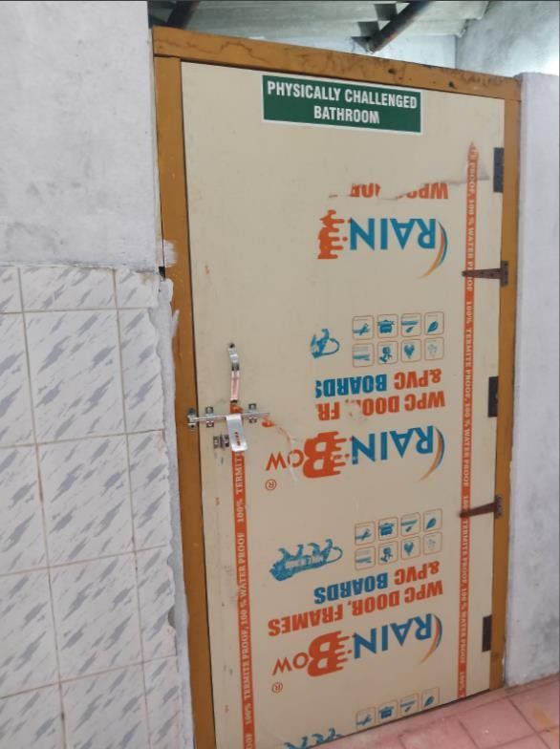

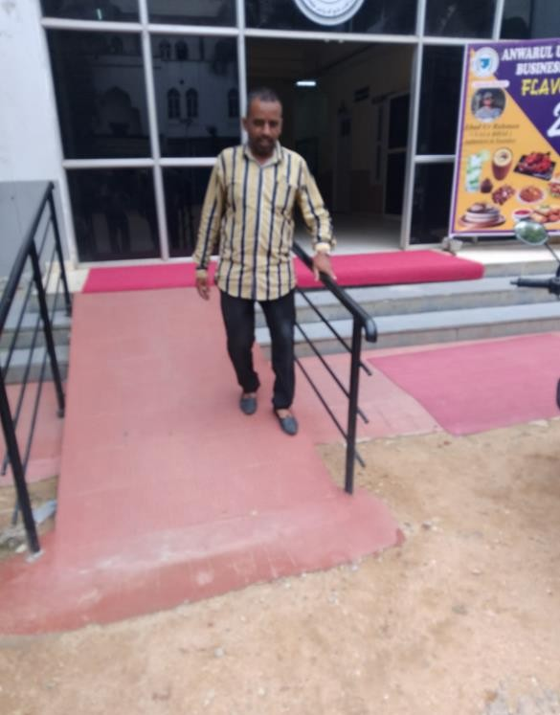

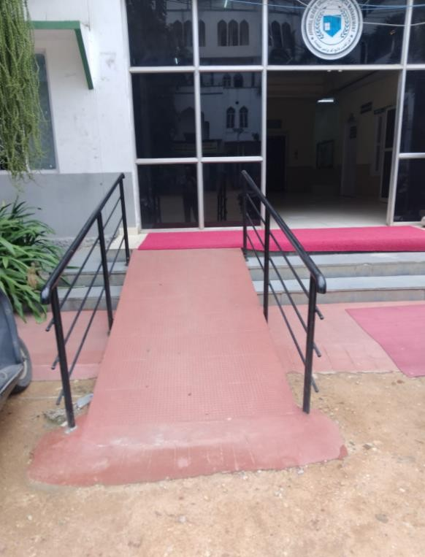

While specific accommodations for differently-abled students are not detailed, the existing facilities can be utilized to support their educational needs.